Final Project

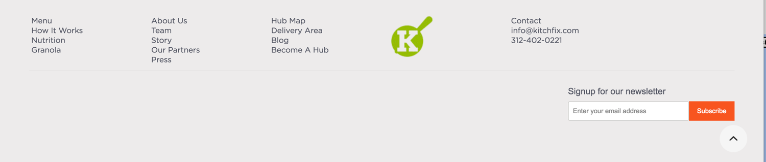Site which Kitchfix customers can use to enter their zip code to find our delivery fee, delivery days/times, and next available delivery window.

ON SUBMIT –

Delivery Fee: $##

Delivery Days:

Monday: ##am-##pm

Tuesday: ##am-##pm

…

…

…

…

Submit

FIELD – your delivery zip code

HEADER – enter your zip code for delivery price, days, and time windows

Image of food

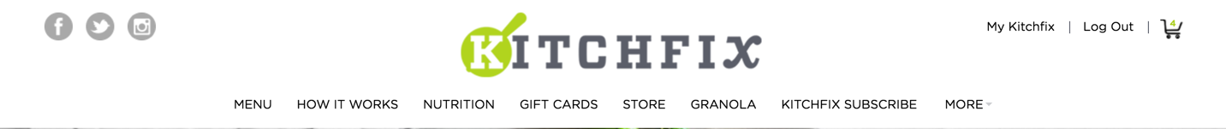

Final Project

Site which Kitchfix customers can use to enter their zip code to find our delivery fee, delivery days/times, and next available delivery window.

BEFORE SUBMIT –

* Explanation of home delivery (for home delivery, we use insulated cooler bag, etc.)
  + Text tracking
* Explanation of hub delivery (come by whenever your hub is open)
  + Link to hub page
* Bag reuse system

Submit

FIELD – your delivery zip code

HEADER – enter your zip code for delivery price, days, and time windows

Image of food

